Table of Contents

1 Introduction 2

1.1 Project Purpose 2

2 Background 3

2.1 Agent-based Modeling 3

2.2 Financial Market Modeling Theories 4

2.2.1 Formula based Financial Market Modeling 4

2.2.2 Agent-based Financial Market Modeling 5

2.2.3 Behavior Financial Method 7

2.3 Agent-based tools 8

3 Agent-based Financial Market Framework Design 9

3.1 Overview and High-level Design 9

3.1.1 Overall Architecture 9

3.1.2 Concept and Implementation Model 9

3.1.3 Market Maker and Financial Product Design 11

3.1.4 Financial Product Design 11

3.2 Information Publisher and Propagation Design 11

3.3 Market Participant and Invest Policy Design 11

3.4 School Design 11

3.5 TensorFlow Connection 12

4 Framework Implementation 12

4.1 Technical Stack Choice 12

4.2 Framework Interface Design 12

4.3 Implementation 12

4.3.1 Framework Implementation model 12

4.3.2 Agent Class MarketMaker 13

4.3.3 Agent Class InfoPublisher 13

4.3.4 Agent Class MktPaticipant 13

4.3.5 Agent Class School 13

5 Framework Performance Tuning 13

6 Financial Market Simulation Using Framework 13

7 Conclusion and Future Work 13

# Introduction

## Project Purpose

(To do: Add some new info)

The simulation of financial market is commonly used by economists or regulators of financial markets. When new theories or conjectures for financial markets are proposed, they need to be verified by simulating the financial market; before the new economic policy or regulations are carried out, they should be evaluated by the simulation of the financial market; when the fluctuation or economic events happened in the financial market is incomprehensible, we can use historical data to replay the market, and study the underlying economic laws the phenomena.

Therefore, since 1970s, new theories and methods have been applied to the simulation of financial market. Among them, the Agent based modelling method is applied to the financial market and is developing continuously because it is very suitable for modelling complex systems. From the early Expectations Equilibrium Model to the Artificial Stock Market Model of the Santa Fe Institute, and to the adaptation of artificial intelligence algorithms and behaviour financial algorithms in recent years, the modelling methods and model of the financial markets have been improved.

However, there are some problems with current approaches, including:

* Most of the implementation of the model are designed to complete a specific financial research topic, so the current model is not universal.
* The characteristics of the investors in the model is too simple, but the classification of investor agent are very complex, their risk tolerance, investment tendency, the number of property will affect their decision.
* The current model only involves the interaction between investors and market makers, but the interaction between investors and investors will also affect their behaviour, and then influence the market.
* The current model is simply divided the assets into risky assets and risk-free assets, but there are many kinds of assets that can be invested in the real financial market. These assets can be defined by the assets' yield, risk coefficient and other parameters. There may are also links between products. Such as stock in the spot market is highly related to the stock options or stock futures in the derivatives market. These relationships are not supported by the current model.
* The current model distinguishes informed and uninformed investors, but we know that the real market is information asymmetric. The path and speed of information transmission and how much the investor trust the information source will affect investors' decision-making. The current model does not reflect such factors well.
* The current implementations and tools do not support AI platform.
* The current financial market simulation can be carried out by using existing Repast, NetLogo and other general agent simulation tools, and Repast HPC version even can run on high performance computer cluster to support more agents and more complex markets. But these tools are not designed for the financial market simulation, so these tools are not easy to use and not easy to expand by the economists. This restricts the efforts of using the Agent-based method to conduct financial market simulation.

Therefore, a generic framework for parallel financial market simulation using agent-based techniques is valuable to be developed. The main aim of the project is to develop this framework and test using an existing data set.

To support this aim, the following objectives will be worked towards:

* Based on the existing Agent-based financial market models, design general abstracted model of financial markets.
* Research and choice of underlying technology and application development for framework.
* Using the developed framework, using existing algorithms and historical real financial data to validate it.

# Background

## Agent-based Modeling

(To do: Renew this section to get a more clear introduction)

The complex systems put forward a challenge to the traditional method of modelling and simulation. In a complex system, every individual of the system interacts with others, reacts to its environment. The overall behaviour of the system is led by every individual’s behaviour. Even the smallest part could influence the system. It’s difficult to model the complex system in a holistic view. Agent-based modelling is a good way to model the complex system because it focuses on the individual instead of the whole system. By modelling the simple individuals to Agents, the performance of the whole system can be observed, which is led by Agents’ activities. No universally accepted definition for Agent-based model (ABM), but in Wikipedia, it is defined as “A class of [computational models](https://en.wikipedia.org/wiki/Computational_models) for [simulating](https://en.wikipedia.org/wiki/Computer_simulation) the actions and interactions of autonomous agents with a view to assessing their effects on the system as a whole” . This definition gives two crucial points of ABM: In the model, agents are autonomous, which means they can process, act and interact with others by themselves. In the model, the purpose of modelling is observing the whole system. This gives a good way to solve the complex of a system.

Agent-based modelling are being used in an increasingly wide variety of applications in many subjects which can be taken as a complex system. Cammarata [5] studied strategies of cooperation for resolving conflicts among plans of a group of agents and applied it to air traffic control. In 2003, Jeffrey designed a Agent-based concept model for military area, then Agent-based modelling is widely used in battle simulation, the Battle of Trafalgar and the Battle of Isandlwana are simulated using Agent-based modelling theory. Agent-based modelling has also been adopted in earthquakes simulation and society simulation. In these applications of Agent-based theory, especially in the simulation applications related to social science, the agents are getting more and more intelligent. Artificial intelligence algorithms are adopted in agents.

## Financial Market Modeling Theories

### Formula based Financial Market Modeling

As we mentioned in Introduction section, simulation of financial market is widely used by economists and regulators, they never stop to find better model to represent and modelling the financial market. Economists have made a lot of efforts to use some simple and straightforward models to simulate the market. These models based on the modern finance theory, including Miller’s arbitrage pricing theory [13], Markowitz’s Portfolio Theory[14], Linter’s theory of Capital Asset Pricing Model [15] and Black, Schoels and Merto’s option pricing theory [16]. These theories try to use a set of formulas to explain the changes of the market. For example, the CAPM.

The CAPM is a model for pricing an individual security or portfolio. For individual securities, we make use of the [security market line](https://en.wikipedia.org/wiki/Security_market_line) (SML) and its relation to expected return and [systematic risk](https://en.wikipedia.org/wiki/Systematic_risk) (beta) to show how the market must price individual securities in relation to their security risk class. The SML enables us to calculate the [reward-to-risk ratio](https://en.wikipedia.org/wiki/Risk%E2%80%93return_spectrum) for any security in relation to that of the overall market. Therefore, when the expected rate of return for any security is deflated by its beta coefficient, the reward-to-risk ratio for any individual security in the market is equal to the market reward-to-risk ratio, thus:

{\displaystyle {\frac {E(R_{i})-R_{f}}{\beta _{i}}}=E(R_{m})-R_{f}}

The market reward-to-risk ratio is effectively the market [risk premium](https://en.wikipedia.org/wiki/Risk_premium) and by rearranging the above equation and solving for {\displaystyle E(R_{i})~~}, we obtain the capital asset pricing model (CAPM).

{\displaystyle E(R_{i})=R_{f}+\beta _{i}(E(R_{m})-R_{f})\,}

where:

* {\displaystyle E(R_{i})~~} is the expected return on the capital asset
* {\displaystyle R_{f}~} is the risk-free rate of interest such as interest arising from government bonds
* {\displaystyle \beta _{i}~~} (the [*beta*](https://en.wikipedia.org/wiki/Beta_(finance))) is the [sensitivity](https://en.wikipedia.org/wiki/Sensitivity_and_specificity) of the expected excess asset returns to the expected excess market returns, or also {\displaystyle \beta _{i}={\frac {\mathrm {Cov} (R_{i},R_{m})}{\mathrm {Var} (R_{m})}}=\rho _{i,m}{\frac {\sigma _{i}}{\sigma _{m}}}}
* {\displaystyle E(R_{m})~} is the expected return of the market
* {\displaystyle E(R_{m})-R_{f}~} is sometimes known as the *market premium* (the difference between the expected market rate of return and the risk-free rate of return).
* {\displaystyle E(R_{i})-R_{f}~} is also known as the *risk premium*
* {\displaystyle \rho _{i,M}} denotes the [correlation coefficient](https://en.wikipedia.org/wiki/Correlation_coefficient) between the investment {\display

But there is always a deviation from the reality, because the financial market is a complex system that cannot be simulated with a simple formula. This complexity is manifested in:

* The price of each financial product is influenced by the trading action of each participant in the market.
* Each participant's trading action is made by his expectation of future price of the financial product.
* Each participant’s expectation is based on the information received, the current price of the financial product and macroeconomic performance of the market.
* Even if a participant predicts the future price of the asset, whether he will make a trading decision also depend on his risk tolerance.
* Many participants are irrational, their decision will be affected by many emotions such as greed, timidity, conformity and so on, which will change their behaviour in the market.
* The decision made by each participant affects the behaviour of other participants who trust him.

It’s obviously that the financial market is a complex system, so Agent-based modelling is a good way to model the financial system.

### Agent-based Financial Market Modeling

#### Expectations Equilibrium Model

Financial market is such a complex system which is difficult to simulate using a simple formula. Therefore, in 1980, Grossman & Stiglitz [17] and Bray [18] try to use the Agent-based Expectations Equilibrium Model to simulate the financial market activities. In their model, it is assumed that there are N agents in the whole market, these agents are categorized into two groups, informed and uninformed. At time point ***t***, each Agent accepts the information ***I*t**, the market price ***P*t** of an financial product and the return ***R*t** of the product. Informed agents calculate its future expectation of product – ***E*** using the information it received. According to the history of price and return of financial product, uninformed agents establish the expectation of asset ***E*** using the ordinary least squares curve. Each Agent want to maintain the market’s balance and modify the amount of the product they required. But the total amount of the product is certain, which cause the changes of the market price of product. This is a simple model, the whole market only contains one product, so there is no interaction between products and each investor agent is a perfect rational individual. That’s different from the real market, but this model laid the foundation of mathematical analysis for the subsequent agent-based financial market model.

#### Artificial Stock Market Model

In 1990, the Santa Fe Research Institute who is famous for their research on complex system began to establish Artificial Stock Market Model [19] based on Expectations Equilibrium Model.

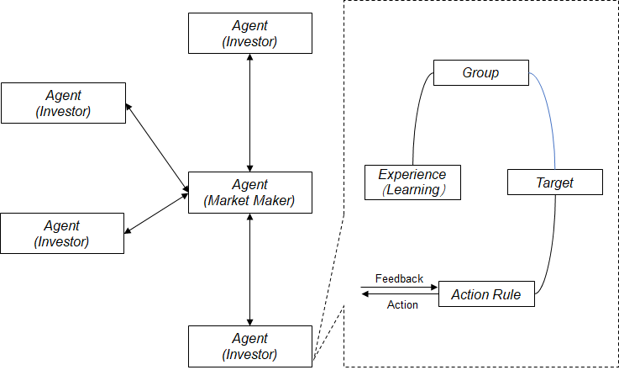

Figure 1: The Logic Graph of Artificial Stock Market Model

This model is more complex and extends in many aspects, including:

* In this model, the investors are not only divided into 2 categories, but are represented by many kinks of agents with a lack of visionary and incomplete rationality. These agents make investment decisions based on their prediction of future market conditions.
* The learning function is added, so each agent can learn from the past experience of investment.
* There are two kinds of financial products in the market: one is the limited supplied risky stocks, the dividend is ***D*t**, the other is the unlimited supplied risk-free bonds, the fixed interest rate is ***R*f**.
* Each Agent is assigned some cash at the beginning of the simulation and in every simulation period, he makes decisions to buy/sell these two securities to set uo their portfolio. The decision is based on their prediction on stock price and the risk of the stock (represented by the price variance). The prediction rule is composed of a set of IF-THEN logic statements.
* In the market, the market maker agent uses match the sell and buy decisions to generate new price of the two financial products.

The prediction rule of a agent is composed of a series of IF-THEN logic statements, like,

***IF (the status of market is D*i*) THEN (a=k*j *, b= k*l*).***

Here, ***D*i** is the market state. ***k*j** and ***k*l** are constants. ***a*** and ***b*** are predictive equation parameters, and their initial values are randomly selected from the uniform distribution function about stock value. The prediction equation is:

***E (p*t+1 *+ d*t+1 *= a (p*t *+ d*t*) + b***

Among them, ***p*t** is the price of stock, ***d*t** is the dividend in time ***t***. Market state descriptor ***{Dt}*** corresponds to the analysis of historical data by stock prices and dividends and determine the state of the market. Therefore, the description is actually a set of boolean functions on a large number of market state. Each state rules for the market reaction can be expressed as a set of binary arrays.1 represents the state is true, the rules are used; 0 represents the condition is false, the rules are used.

In the Artificial Stock Market model, the learning function is implemented using the genetic algorithm(GA), which can improve the rule of judgement by eliminating the rules that proved ineffective and produces new rules by mutation from the old ones.

#### The Extension of the Artificial Stock Market Model

Although the artificial stock market model has made great progress, it still cannot satisfy all economists' need for market exploration and simulation. Chen and Yeh. [20] modified the learning mechanism in the model, set up schools in the market, so that agents can learn successful skills in school, so that good rules can be spread between agents. On the specific implementation, they use Single Global genetic Algorithm or Single Genetic Programming (SGA/SGP) to replace Multi Genetic Algorithm or Multi Genetic Programming (MSA/MSP) in the market. That means using interactive learning to replace individual learning. Lttau[21] modified the hypothesis of ASM in his model to better observe agent's response to market. He assumed that the price of assets is exogenous. Arifovic [22] uses a dynamic learning mechanism instead of genetic algorithm in a research based on ASM model for foreign exchange market research.

Beltratti & Margarita [23] and Beltratti et al. [24] put forth an interesting market structure. In their model, agents forecast future prices using an artificial neural network. This neural network is trained with several inputs including several lagged prices, and trade prices averaged over all agents from earlier periods. Agents are randomly matched, and trade occurs when agent pairs have different expected future prices.

### Behavior Financial Method

Behavioral finance theory is to study people's cognition and sense in the process of investment decision making. The psychological characteristics of sentiment and attitude, and the market inefficiency caused by it can explain the abnormal phenomena in stock market. In view of the large impact of the psychological factors in the decision-making process of the retail investors, the behavioral finance term value theory is introduced to model the retail investors. This section will introduce the related contents of Finance and expected value theory in detail.

## Agent-based tools

There are many free or open source ABM software tools, including Repast, Swarm, StarLogo, NetLogo, Aspen, AgentSheets, Ascape, etc.

The common ABM tools include:

***Repast***

The Repast is a family of advanced, free, and open source agent-based modeling and simulation platforms that have collectively been under continuous development for over 15 years [11]. Its characteristics include: Complete discrete event scheduling method; Model visualization environment; Modelling Agent with GIS; Adaptive behaviour modelling tools (such as neural networks, genetic algorithms, etc).

Repast supports languages such as Java, C + +, C#, VB, Lisp, and Prolog. There are 2 software included in Repast: [Repast Simphony](https://repast.github.io/repast_simphony.html) ,which  is a richly interactive and easy to learn Java-based modelling system that is designed for use on workstations and small computing clusters. Repast HPC, which is a lean and expert-focused C++-based modelling system that is designed for use on large computing clusters and supercomputers.

***Swarm***

Swarm is a common platform for complex system simulation based on Agent, which can run in the Unix /Linux and Windows environment. Swarm was developed in the Objective C language and provided support for Java from the edition 2. Swarm provides an implementation of the Agent-based model which is established and shared by object library and has an operation-based control engine and provides a user interface for modelling observation.

***StarLogo***

StarLogo was originally used to explore large-scale parallel computing based on personal computers to help students understand complex systems through simulation, and later several variants are mainly used for social domain simulation.

***NetLogo***

NetLogo is a programmable modelling environment for simulation of natural and social phenomena. It was launched in 1999 and is responsible for continuous development by link learning and Computer Modelling Centre (CCL). Its purpose is to provide a powerful and easy-to-use computer aided tool for scientific research institutions. NetLogo inherits from the Logo language, but it can control the tens of thousands of Agents. therefore, in the modelling, NetLogo can well simulate the micro individual behaviour and macro mode of connection.

A paper summarizes and compares some of the current Agent modelling toolkits based on the Java language.

# Agent-based Financial Market Framework Design

## Overview and High-level Design

### Overall Architecture

The entire framework is based on the Repast HPC library and the C++ standard library and the boost library. Framework invokes the interfaces of underlying libraries such as Repast HPC, C++ and MPI. At the same time, the framework provides API interfaces to application programs.

The overall logic architecture is showed in figure 2.

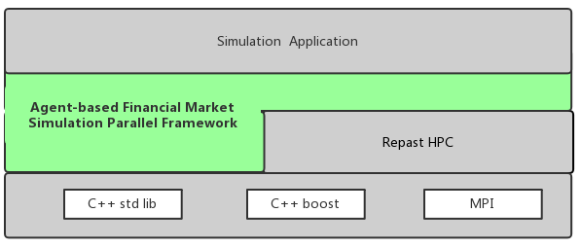

### Concept and Implementation Model

#### Framework Concept Model

The framework provides a more general market concept model. The basic concepts of the model include:

***Financial Products:*** financial products are assets that can be acquired through transactions. Financial products have the attribute of price. Product can be defined according to the properties of the rate of return, the level of risk, the bonus plan and so on.

***Financial Products Group:*** financial products with similar attributes can be divided into product groups, which are used for statistics and judgment.

***Currency***: Currency is the unit of the price of a financial product. The exchange rate can be set between different currencies, and the exchange rate can be kept constant and can be updated dynamically.

***Investor***: the investor is the person who holds the currency and expects to buy the financial assets using money to achieve the desired goal. Investors receive information, predict the future price of financial products based on forecast rules, and make decisions to buy or sell according to this. The investor has the location attribute, the personality attribute and the category attribute. The location attribute represents the location information of the investor; the personality attribute represents the investor's personality and the degree to which it is in this personality. For example, the degree of rationality, the degree of risk tolerance, the degree of greed, the degree of independent judgment, etc.; category attributes identify the classification of investors. The investor has the learning function and can update the prediction rules according to the historical investment information.

***Information***: information is the message that the market participants send, contain specific meaning which will affect the investor's expectation of the financial product. Information can be expressed in positive or negative numbers in the model and carries attribute values to indicate which range of financial products can be affected, and which specific categories of investors can be affected.

***Market Maker***: market maker is responsible for receiving the decision of the investors to buy or sell and match them to form new price information and send to the whole market.

***Information Source***: the information source is a participant in the market that sends out information. The listed companies, market media and private investment clubs can all be the information sources. The information source has the location attribute and the trust attribute of investors. An investor with specific categories and attributes can have a different degree of trust in the information issued by a source.

***School***: retaining the school function in the previous model, investors can get and update the prediction rules from the school

***Domain***: each location attribute belongs to one or more regions, and each concept with a location attribute will automatically belong to one area. The region can be used to simulate the border of the country, and then to simulate the relationship between the international markets.

The concept model is shown as shown in the figure.

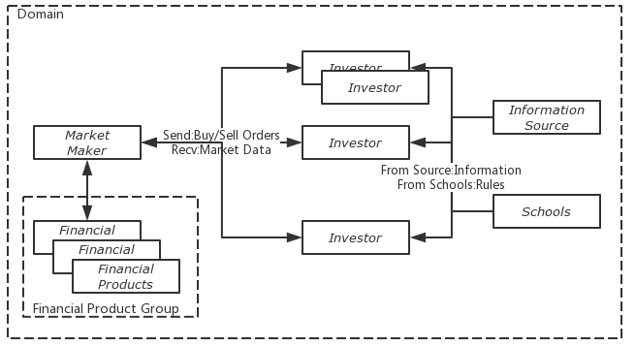

### Market Maker and Financial Product Design

### Financial Product Design

Financial products are trading products in financial markets, designed to meet people's financing, investment and risk control needs to their wealth.

There are many kinds of financial products, including stocks, bonds, derivatives and so on. All these products can be classified into two kinds:

**Fundamental Products**, including stocks, bonds, funds. These products deal with rights and interests. Fundamental product accepts the order and immediately completes the conversion of the real ownership, which includes a company's share certificate, a debt certificate, a fund's share proof, etc. The person who pays the money and receives the certificates enjoys various rights and interests based on the certificates, including voting, dividends, etc.

**Derivative Products**, which can be seen as a contract. This contract is usually related to a fundamental product. The contract specifies the rights and responsibilities of the multiple parties in this transaction.

Forward trading - the obligation of both parties to engage in basic products trading at a specific price at any time in the future. There is no transfer of assets now.

Futures trading - a floor transaction where the two parties are agreed to make a basic product transaction at a specific price in the future. There are transactions in the current period, and transactions are obligations, not rights.

Option trading - the right of both parties to make a basic product transaction at a specific price in the future. There is a deal at the present time.

Credit derivatives -

CDS- credit default swap - the buyer's purchase of the cost paid to the other party in exchange for risk at the time when the other party takes the risk.

From the analysis above, the basic information model is:

Action：

Receive Trading Order

Broadcast Market Data

Send Private Data

Receive Other Info/Trigger

Properties

Product Status

Product Holdings

Product Orderbook

Market Maker model:

Properties

Product List(Object List)

Action:

MktDataBroadcast

Receive Orders

## Information Publisher and Propagation Design

## Market Participant and Invest Policy Design

## School Design

## TensorFlow Connection

# Framework Implementation

## Technical Stack Choice

Backend Language

Interface Language

Agent Tools

## Framework Interface Design

## Implementation

### Framework Implementation model

When implementing the framework, market makers, investors, information sources, schools and so on can be designed as agent and will be deployed on different nodes according to user specified policies. At the same time, the whole system also needs a node to monitor and manage the entire simulation market, and we can simulate some news through this node to change the behaviour of the market. As shown in the following figure.

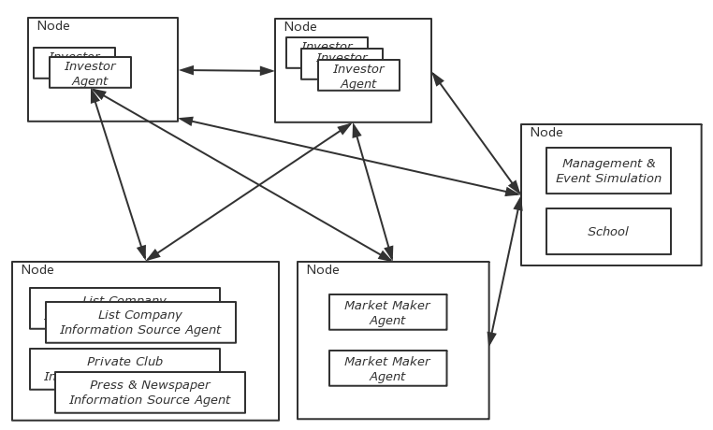

The API provided by the framework will refer to the Repast HPC library. All of these Agents and their built-in behaviour and properties are provided in the form of the basic class in C++. Users can develop their own classes to inherit one or more basic classes to form their own Agent class. User can override some behaviours or add special behaviours and attributes in their Agent class.

Some algorithms are used in the framework to learn rules. To make Agent more intelligent, we need to make the framework connect with the Deep Learning platform such as TensorFlow. Every Agent should be able to directly call the function of Deep Learning platform in the framework.

### Agent Class MarketMaker

### Agent Class InfoPublisher

### Agent Class MktPaticipant

### Agent Class School

# Framework Performance Tuning

# Financial Market Simulation Using Framework

# Conclusion and Fut ure Work